

CS3343 Software Engineering Practice
Test Report (Group 5)
Project Title: Sport Facility and Equipment Booking System

Name | Student Number
NG Ka Hung | 58533046
LIN Weiyuan | 58537684
LAU Wing Him | 58537137
IP Wing Kai | 58120400
LEE Kin Wai | 57925345
Chan Sing To | 58533974

Table of Content
1. TESTING MODULE HIERARCHY 3
2. Testing Strategy: Bottom-up Approach 4
2.1 UNIT TEST 4
2.2 INTEGRATION TEST 4
2.3 SYSTEM TEST 6
3. Pre-Refactoring & Post-Refacotring Testing 11
4. C/DC Coverage 12
5. Test Cases 13

1. Testing Module Hierarchy
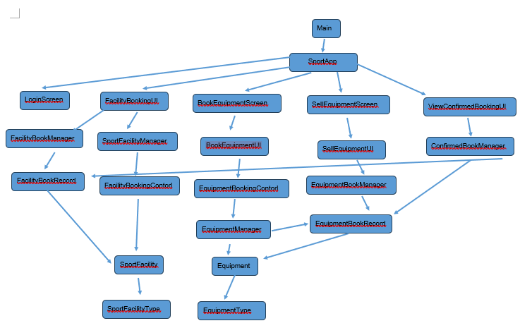Our application follows a hierarchical tree structure centered on the SportApp controller. Clearly dividing the system into three distinct layers:
- Presentation Layer: The "Screens" and "UIs" that handle user interaction.
- Logic Layer: The "Managers" and "Controls" that process rules and transactions.
- Data Layer: The "Records" that store persistent information.
Functional Branches: The application is organized into five parallel workflows:
- Authentication: A standalone LoginScreen for entry.
- Facility Management: Handles venue reservations. It flows from the UI to FacilityBookManager and connects SportFacility entities with transaction records (FacilityBookRecord).
- Equipment Booking: Manages item rentals. It routes logic through an EquipmentManager to link physical inventory (Equipment) with booking data.
- Equipment Sales: A dedicated branch for selling items, utilizing shared logic with the booking system via the EquipmentBookManager.
- Confirmation & Review: The ViewConfirmedBookingUI uses a specialized manager to pull data from both Facility and Equipment records, providing a unified view of all user activities.

2. Testing Strategy: Bottom-up Approach
Bottom-Up Testing is an integration testing strategy where testing starts with the lowest-level components (modules that do not depend on others) and progressively works up the hierarchy to the top-level modules (like the Main Menu or UI).
Also, a bottom-up approach can avoid complex test stubs. In Top-Down testing, if developers tested the UI first, they would need to write fake code (stubs) to simulate the Manager because the Manager wouldn't be ready yet. By building the EquipmentManager first, our BookEquipmentUI can use the real manager immediately. We save time by not writing fake "placeholder" code.

2.1 UNIT TEST
- SportFacilityType
Purpose: Ensures that our fundamental data structure handles data correctly, preventing silent errors from causing bugs in the higher-level Managers and User Interfaces that depend on it.
- EquipmentType
Purpose: Ensures that our fundamental data structure handles data correctly, preventing silent errors from causing bugs in the higher-level Managers and User Interfaces that depend on it.
- Login Screen
Purpose: Check whether user can be identified by username and password

2.2 INTEGRATION TEST
After completed Unit Test, we continue the integration test for testing the components of the system. The purpose of the integration test is to check if base classes can work and communicate with each other to perform expected function.

Integration 1:
EquipmentManager
+ EquipmentBookManager
+ EquipmentBookRecord
+ EquipmentBookingControl
+ EquipmentType
+ Equipment

Purpose:
Verify that EquipmentBookRecord can communicate with EquipmentManager and EquipmentBookManager, and generate EquipmentBookRecord and store it in EquipmentBookManager while updating the status of Equipment through EquipmentManager.

Integration 2:
SportFacilityManager
+ FacilityBookManager
+ FacilityBookRecord
+ FacilityBookingControl
+ SportFacility
+ SportFacilityType

Purpose:
Verify that FacilityBookRecord can communicate with SportFacilityManager and FacilityBookManager, and generate FacilityBookRecord and store it in FacilityBookManager while updating the status of SportFacility through SportFacilityManager.

Integration 3:
FacilityBookingUI
+ SportFacilityManager
+ FacilityBookManager
+ FacilityBookRecord
+ FacilityBookingControl
+ SportFacilityType
+ SportFacility

Purpose:
Verify that the user can book an available facility in FacilityBookingUI and communicate with business logic,integration 2, for processing booking.

Integration 4:
BookEquipmentScreen
+ BookEquipmentUI
+ EquipmentManager
+ EquipmentBookManager
+ EquipmentBookRecord
+ EquipmentBookingControl
+ EquipmentType
+ Equipment

Purpose:
Verify that BookEquipmentScreen can connect with the business interface, BookEquipmentUI, and the user can book an available equipment in BookEquipmentScreen and BookEquipmentUI can communicate with business logic,integration 1, for processing booking.

Integration 5:
SellEquipmentScreen
+ SellEquipmentUI
+ EquipmentManager
+ EquipmentBookManager
+ EquipmentBookRecord
+ EquipmentBookingControl
+ EquipmentType
+ Equipment

Purpose:
Verify that SellEquipmentScreen can connect with business interface, SellEquipmentUI, and the user can purchase an available equipment in SellEquipmentScreen and SellEquipmentUI can communicate with business logic,integration 1, for processing purchasing.

Integration 6:
ViewConfirmedBookingUI + ConfirmBookManager

Purpose:
Verify that all the booking record store in ConfirmBookManager and can be viewed in ViewConfirmedBookingUI

2.3 SYSTEM TEST
System Test is the final phrase of the whole testing. The tester will perform some operations on the system to mimic the events that might happen in reality. As a consequently, the system will be conducted in a fully completed, seamless environment to assess the extent to which the system will match with our expectations.
In order to achieve that, blackbox testing will be adopted in system testing. Therefore no code information is assumed and provided to the tester. Instead, some various and comprehensive case scenarios are designed for scalable testing programs. The tester will play a role of user in those scenarios.

Test 1: Borrow equipment Test
Expected: Any available quantity of equipment can be booked and displayed at shopping cart(ViewCurrentBookingUI)
======= Home Page =======
1. Sport Facility Booking
2. Sport Equipment Booking
3. View Pending Booking
4. View Booking Record
L. Logout
E. Exit
========================
Please input function number (1-5), Logout (L) or Exit (E): 2

Booking User: admin
1. 2025-11-24 || SF-001 || 10-12
2. 2025-11-25 || SF-003 || 12-13
3. 2025-11-26 || SF-001 || 9-10
Please select a booked facility [1 ~ 3] or go back [0]: 1

=== Equipment Rental and Sales ===
1. Borrow Equipment
2. Buy Equipment
H. Go back to Home Page
==============================
Please select an option (1-2) or go back (H): 1

========================== Equipment Rental ===========================
|| ID || Equipment Type || Available || Price ||
=======================================================================
|| ET-001 || Basketball Brand A || 9 || $15/Hour ||
|| ET-002 || Basketball Brand B || 10 || $20/Hour ||
=======================================================================
Please input Equipment ID and Quantity separately.
Please input Equipment Type ID (e.g ET-001): ET-001
Please input the quantity or input [0] go back.
2
Success borrow BASKA-002 Basketball Brand A by admin
Success borrow BASKA-003 Basketball Brand A by admin
Do you want to go back Book Equipment Page [B] or Home Page [H]?
H

======= Home Page =======
1. Sport Facility Booking
2. Sport Equipment Booking
3. View Pending Booking
4. View Booking Record
L. Logout
E. Exit
========================
Please input function number (1-5), Logout (L) or Exit (E): 3

================================ Current Booking (Shopping Cart) ==================================================
|| No. || Date || Facility/Equipment || Time || Status ||Price ||
===================================================================================================================
|| 1 || 2025-11-24 || SF-001 || 10:00 - 12:00 || PENDING || 60.0 ||
|| 2 || 2025-11-25 || SF-003 || 12:00 - 13:00 || PENDING || 15.0 ||
|| 3 || 2025-11-26 || SF-001 || 09:00 - 10:00 || PENDING || 30.0 ||
|| 4 || 2025-11-24 || Basketball Brand A x 1 || 10:00 - 12:00 || PENDING || 15.0 ||
|| 5 || 2025-11-24 || Basketball Brand A x 2 || 10:00 - 12:00 || PENDING || 30.0 ||
|| 6 || 2025-11-25 || Basketball Brand A x 1 || 10:00 - 12:00 || PENDING || 15.0 ||
|| 7 || 2025-11-26 || Basketball Brand A x 1 || 10:00 - 12:00 || PENDING || 15.0 ||
===================================================================================================================
|| Total price: 180.0 ||
===================================================================================================================

Test 2: Borrow facility test
Expected: Any available facility can be booked and displayed at shopping cart (ViewCurrentBookingUI)
======= Home Page =======
1. Sport Facility Booking
2. Sport Equipment Booking
3. View Pending Booking
4. View Booking Record
L. Logout
E. Exit
========================
Please input function number (1-5), Logout (L) or Exit (E): 1

User admin is booking facility.
================ Available Sport Facilities =================
|| No. || Facility Name || Type ||
=============================================================
|| 1 || SF-001 || Basketball ||
|| 2 || SF-002 || Badminton ||
|| 3 || SF-003 || TableTennis ||
=============================================================
Select the facility to book (Enter the number): 3
Which day you want to book a SFT-003? e.g. 22/09/2025
30/11/2025
Available time slots on 2025-11-30 are:
1 . 9:00 - 21:00
number of existing booking5
Please input the start hour
9
Please input the end hour
12
number of existing booking after 6
admin
Booking confirmed for: SF-003
Date: 2025-11-30
Time: 9 - 12

Late return of facility will face penalty!

Do you want to book another facility/time slot? (y/n): n

======= Home Page =======
1. Sport Facility Booking
2. Sport Equipment Booking
3. View Pending Booking
4. View Booking Record
L. Logout
E. Exit
========================
Please input function number (1-5), Logout (L) or Exit (E): 3

================================ Current Booking (Shopping Cart) ==================================================
|| No. || Date || Facility/Equipment || Time || Status ||Price ||
===================================================================================================================
|| 1 || 2025-11-24 || SF-001 || 10:00 - 12:00 || PENDING || 60.0 ||
|| 2 || 2025-11-25 || SF-003 || 12:00 - 13:00 || PENDING || 15.0 ||
|| 3 || 2025-11-26 || SF-001 || 09:00 - 10:00 || PENDING || 30.0 ||
|| 4 || 2025-11-30 || SF-003 || 09:00 - 12:00 || PENDING || 45.0 ||
|| 5 || 2025-11-24 || Basketball Brand A x 1 || 10:00 - 12:00 || PENDING || 15.0 ||
|| 6 || 2025-11-25 || Basketball Brand A x 1 || 10:00 - 12:00 || PENDING || 15.0 ||
|| 7 || 2025-11-26 || Basketball Brand A x 1 || 10:00 - 12:00 || PENDING || 15.0 ||
===================================================================================================================
|| Total price: 195.0 ||
===================================================================================================================

3. Pre-Refactoring & Post-Refactoring Testing
The test data remained consistent throughout the refactoring process. The figure on the right illustrates the post-refactoring coverage. Critical modules achieved 100% coverage, with the only distinction between the pre- and post-refactoring states being a change in the number of branches. Modules exhibiting less than full coverage are either non-critical testing utilities or User Interface components, which fall outside the scope of automated testing.

Pre-Refactoring:
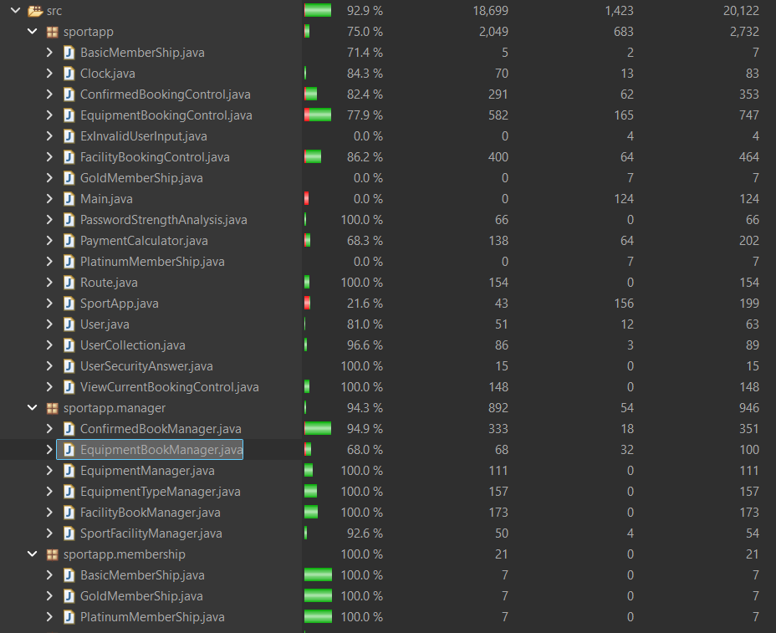
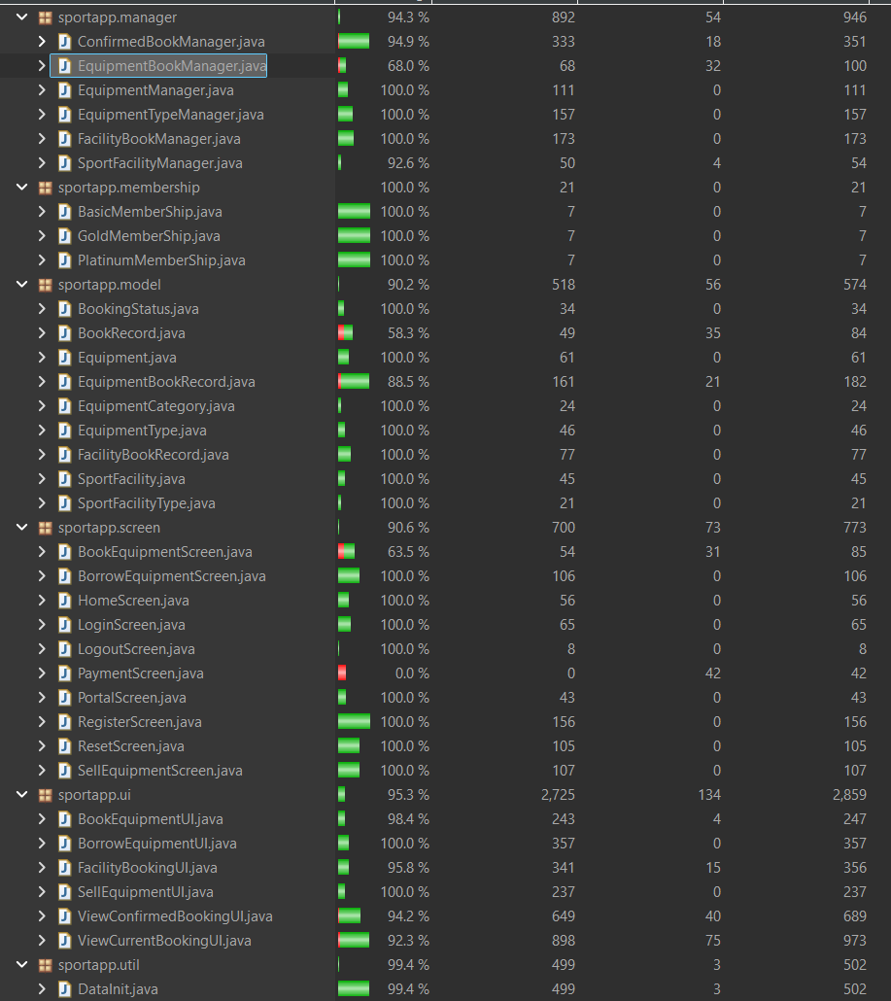

Pre-Refactoring:

4. C/DC Coverage
In the testing process, two types of predicate testing will be adopted: Condition Coverage (CC) and Decision Coverage (DC). Condition coverage will evaluate each condition to be true or false. On the other hand, decision coverage is used to evaluate each decision to be true or false. In order to achieve a comprehensive testing, C/DC coverage will be applied. Such testing requires the test case to be satisfied both CC and DC. Here are examples in the class BookingGapCalculator.
Source Code:
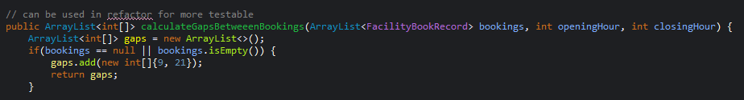

Truth Table for Test Cases 1-3:
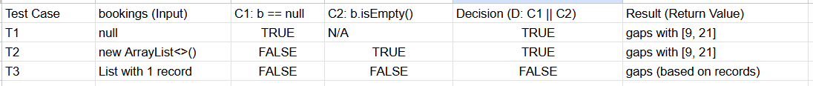

5. Test Cases
We have a total of 141 test cases to ensure high quality and reliability of the system. The following are test cases for each class.
BasicMemberShip.java
Purpose: verifies that the BasicMemberShip class, which represents the base membership tier, adheres to its expected business rules, primarily concerning its pricing and benefits.
Test case ID | Input Description | Expected Result | Actual Output
T001 | Call getDiscountRate() on a newly initialized BasicMemberShip object. | Returns 0.0 (No discount applied). | As expected
T002 | Call getPrice() on a newly initialized BasicMemberShip object. | Returns 0.0 (The membership itself is free). | As expected

BookEquipmentUI.java
Purpose: ensure that the user interface logic—specifically the private selectFunction method within BookEquipmentUI—correctly processes user input and returns the appropriate navigation route.
Test case ID | Input Description | Expected Result | Actual Output
T003 | testSelectFunctionBorrowEquipment | The method returns the Route.BORROW_EQUIPMENT enum value. | As expected
T004 | testSelectFunctionSellEquipment | The method returns the Route.SELL_EQUIPMENT enum value. | As expected
T005 | testSelectFunctionGoBack | The method returns the Route.HOME enum value. | As expected
T006 | testSelectFunctionInvalidThenValid | The method ignores the invalid input (X) and successfully returns the Route.BORROW_EQUIPMENT enum value based on the second, valid input (1). | As expected

GoldMembership.java
Purpose: ensure the correct implementation of the financial contract and benefits associated with the Gold Membership tier.
Test case ID | Input Description | Expected Result | Actual Output
T007 | test_getDiscountRate() | The method returns 0.20 (representing a 20% discount rate). | As expected
T008 | test_getPrice() | The method returns 50.0 (representing the cost of the Gold Membership). | As expected

HomeScreen.java
Purpose: ensure that the main navigation menu (HomeScreen) correctly captures user input and maps valid menu choices to the corresponding navigation routes.
Test case ID | Input Description | Expected Result | Actual Output
T009 | testDisplay_FacilityBookingChoice | Returns Route.FACILITY_BOOKING. | As expected
T010 | testDisplay_BookEquipmentChoice | Returns Route.BOOK_EQUIPMENT. | As expected
T011 | testDisplay_CurrentBookingsChoice | Returns Route.CURRENT_BOOKINGS. | As expected
T012 | testDisplay_ConfirmedBookingsChoice | Returns Route.CONFIRMED_BOOKINGS. | As expected
T013 | testDisplay_LogoutChoice | Returns Route.LOGOUT. | As expected
T014 | testDisplay_ExitChoice | Returns Route.EXIT. | As expected
T015 | testDisplay_InvalidInputChoice | Returns Route.HOME. (Based on the assertion logic: assertEquals(Route.HOME, result); for the second input E failing, or expecting the loop to finish on a valid route). | As expected

LoginScreen.java
Purpose: ensure the security and reliability of the application's authentication process.
Test case ID | Input Description | Expected Result | Actual Output
T016 | testDisplay_SuccessfulLogin | Returns Route.HOME. The SportApp's currentUser is set to "bot". | As expected
T017 | testDisplay_FailedLogin_Continue | Returns Route.LOGIN. The SportApp's currentUser remains null. | As expected
T018 | testDisplay_FailedLogin_NotContinue | Returns Route.PORTAL. | As expected.

LoginScreen.java
Purpose: the LogoutScreenTest class is to ensure the correct termination of the user session and the proper redirection of the application flow.
Test case ID | Input Description | Expected Result | Actual Output
T019 | testDisplay_Logout | Returns Route.PORTAL. | As expected

PasswordStrengthAnalysis.java
Purpose: the PasswordStrengthAnalysisTest class is to ensure the security policy for user passwords is correctly enforced by the static method isStrongPassword().
Test case ID | Input Description | Expected Result | Actual Output
T020 | test_isStrongPassword_Strong | Returns true. | As expected
T021 | test_isStrongPassword_Weak_LessThan8 | Returns false. | As expected
T022 | test_isStrongPassword_Weak_MissingUppercase | Returns false. | As expected
T023 | test_isStrongPassword_Weak_MissingLowercase | Returns false. | As expected
T024 | test_isStrongPassword_Weak_MissingDigit | Returns false. | As expected
T025 | test_isStrongPassword_Weak_MissingSymbol | Returns false. | As expected

PlatinumMembership.java
Purpose: the PlatinumMemberShipTest class is to rigorously verify the highest tier's financial contract and premium benefits.
Test case ID | Input Description | Expected Result | Actual Output
T026 | test_getDiscountRate() | The method returns 0.40 (representing a 40% discount rate). | As Expected
T027 | test_getPrice() | The method returns 100.0 (representing the cost of the Platinum Membership). | As Expected

PortalScreen.java
Purpose: the PortalScreenTest class is to verify the initial entry point into the SportApp.
Test case ID | Input Description | Expected Result | Actual Output
T028 | testDisplay_LoginChoice | Returns Route.LOGIN. | As Expected
T029 | testDisplay_RegisterChoice | Returns Route.REGISTER. | As Expected
T030 | testDisplay_ResetChoice | Returns Route.RESET. | As Expected
T031 | testDisplay_ExitChoice | Returns Route.EXIT. | As Expected
T032 | testDisplay_InvalidInputChoice | Returns Route.PORTAL. | As Expected

RegisterScreen.java
Purpose: the RegisterScreenTest class is to thoroughly validate the user registration workflow.
Test case ID | Input Description | Expected Result | Actual Output
T033 | testSuccessfulRegistration | Returns Route.HOME. The user ("newUser") is successfully created and added to the UserCollection. | As Expected
T034 | testUsernameAlreadyTakenThenSuccess | Returns Route.HOME. The first attempt is rejected; the user chooses Yes (Y) to retry, enters a new unique username ("newUser"), and is successfully registered. | As Expected
T035 | testWeakPasswordThenSuccess | Returns Route.HOME. The first password ("weak") is rejected; the user chooses Yes (Y) to retry and successfully registers with a strong password ("StrongPass1!"). | As Expected
T036 | testAbortOnUsernameConflict | Returns Route.PORTAL. The user attempts to register with a taken username ("taken"), is prompted to retry, and chooses No (N), aborting the registration process back to the portal. | As Expected
T037 | testAbortOnWeakPassword | Returns Route.PORTAL. The user enters a weak password ("weak"), is prompted to try a stronger one, and chooses No (N), aborting the registration process back to the portal. | As Expected

ResetScreen.java
Test case ID | Input Description | Expected Result | Actual Output
T038 | testDisplay_SuccessfulReset: Existing user ("bot"), correct security answer ("21"), and a strong new password ("StrongP@ss1"). | Returns Route.HOME. Password is changed to "StrongP@ss1". | As Expected
T039 | testDisplay_FailedReset_NonExistentUser: Non-existent username ("Tommy"). | Returns Route.PORTAL. Password remains unchanged. | As Expected
T040 | testDisplay_FailedReset_WrongSecurityAnswer_Continue: Existing user, incorrect security answer ("20"), followed by choice to continue (Y). | Returns Route.RESET or Route.LOGIN. Password remains unchanged ("12345"). | As Expected
T041 | testDisplay_FailedReset_WrongSecurityAnswer_NotContinue: Existing user, incorrect security answer ("20"), followed by choice to abort (N). | Returns Route.PORTAL. Password remains unchanged ("12345"). | As Expected
T042 | testDisplay_FailedReset_WeakPassword_Continue: Correct security answer, weak new password ("weakpass"), choice to retry (Y), then strong new password ("StrongP@ss1"). | Returns Route.HOME. Password is successfully changed to "StrongP@ss1". | As Expected
T043 | testDisplay_FailedReset_WeakPassword_NotContinue: Correct security answer, weak new password ("weakpass"), then choice to abort (N). | Returns Route.PORTAL. Password remains unchanged ("12345"). | As Expected

SportApp.java

Test case ID | Input Description | Expected Result | Actual Output
T044 | test_setAndGetCurrentUser(): A User object is set as the current user. | The getCurrentUser() method returns the exact User object that was set. | As Expected
T045 | test_ContinueOrNot_Continue(): The static method is called with a predefined choice of "Y". | Returns true. | As Expected
T046 | test_ContinueOrNot_NotContinue(): The static method is called with a predefined choice of "N". | Returns false. | As Expected
T047 | test_ContinueOrNot_InvalidChoice_Continue(): The method is called with an invalid choice "X", followed by a valid choice "Y" read from a mock input stream. | Returns true (The method ignores the invalid input and reads the valid follow-up choice). | As Expected
T048 | test_ContinueOrNot_InvalidChoice_NotContinue(): The method is called with an invalid choice "X", followed by a valid choice "N" read from a mock input stream. | Returns false (The method ignores the invalid input and reads the valid follow-up choice). | As Expected

BookEquipment.java

Test case ID | Input Description | Expected Result | Actual Output
T049 | test_display_Borrow(): User inputs the sequence 1\n1\n (e.g., Select Equipment Option, then Select Borrow). | Returns Route.BORROW_EQUIPMENT. | As Expected
T050 | test_display_Sell(): User inputs the sequence 1\n2\n (e.g., Select Equipment Option, then Select Sell). | Returns Route.SELL_EQUIPMENT. | As Expected
T051 | test_display_Home(): User inputs the sequence 1\nH\n (e.g., Select Equipment Option, then Select Home). | Returns Route.HOME. | As Expected
T052 | test_display_ErrorMessage(): User inputs the sequence 1\nW\nH\n (Invalid input W, followed by valid input H). | Returns Route.HOME (Verifies the invalid input is handled and the subsequent valid input is processed). | As Expected

BorrowEquipmentScreen.java
Test case ID | Input Description | Expected Result | Actual Output
T053 | test_display_borrowEquipment_confirm(): User inputs 1\nET-001\n3\nC\n (Select Equipment Type ET-001, Quantity 3, then Confirm C). | Returns Route.CONFIRM_BOOKING. A new equipment record is verified to be created. | As Expected
T054 | test_display_borrowEquipment_back(): User inputs 1\nET-001\n3\nB\n (Select Type, Quantity 3, then Back B). | Returns Route.BACK. An equipment record is verified to be created, and the application navigates back. | As Expected
T055 | test_display_borrowEquipment_home(): User inputs 1\nET-001\n3\nH\n (Select Type, Quantity 3, then Home H). | Returns Route.HOME. An equipment record is verified to be created, and the application navigates home. | As Expected

Clock.java
Test case ID | Input Description | Expected Result | Actual Output
T056 | testGetNow(): Calls the getNow() method. | Returns the current system time, truncated to the second. | As Expected
T057 | testGetToday(): Calls the getToday() method. | Returns the current system date (LocalDate). | As Expected
T058 | testGetHour(): Calls the getHour() method. | Returns the current hour as an integer. | As Expected

DataInit.java
Test case ID | Input Description | Expected Result | Actual Output
T059 | testLoadEquipmentRecords(): Loads default data and checks equipment records for user "admin". | The "admin" user has a total of 6 equipment booking records, with 3 confirmed and 3 pending. | As Expected
T060 | testLoadFacilityRecords(): Loads default data and checks facility records for user "admin". | The "admin" user has a total of 5 facility records, with 2 confirmed and 3 pending. | As Expected

Equipment.java
Test case ID | Input Description | Expected Result | Actual Output
T061 | TestGetEquipmentID(): Checks the generated ID format for a new Equipment object. | Returns a correctly formatted ID string (e.g., E-000001). | As Expected
T062 | TestGetEquipmentName(): Calls the name getter on a borrowable equipment item. | Returns the type name: "Basketball Brand A". | As Expected
T063 | TestGetEquipmentType(): Calls the type object getter on a borrowable equipment item. | Returns the associated EquipmentType object. | As Expected
T064 | TestGetEquipmentTypeName(): Calls the type name getter on a borrowable equipment item. | Returns the type name: "Basketball Brand A". | As Expected
T065 | TestGetEquipmentPrice(): Calls the price getter on a borrowable equipment item. | Returns the price: 15. | As Expected
T066 | TestGetEquipmentCategory(): Calls the category getter on a borrowable equipment item. | Returns the category: EquipmentCategory.BORROWABLE. | As Expected
T067 | TestIsBorrowableEquipment(): Calls the isBorrowable() method on a borrowable item. | Returns true. | As Expected
T068 | TestIsSellableEquipment(): Calls the isSellable() method on a sellable item. | Returns true. | As Expected
T069 | TestGetEquipmentTypeID(): Calls the ID getter on an EquipmentType object. | Returns the ID: "ET-001". | As Expected
T070 | TestGetSportType(): Calls the sport type getter on different EquipmentType objects. | Returns the correct corresponding sport type string (e.g., "Basketball"). | As Expected
T071 | TestEquipmentTypeCompareTo(): Compares two EquipmentType objects using the compareTo() method. | Returns a value consistent with the defined comparison logic (Asserted to be true). | As Expected

EquipmentManager.java
Test case ID | Input Description | Expected Result | Actual Output
T072 | TestGetBorrowEquipment(): Adds 5 borrowable items and retrieves the entire borrowable collection. | Returns the ArrayList containing the 5 borrowable equipment items. | As Expected
T073 | TestGetSellEquipment(): Adds 1 sellable item and retrieves the entire sellable collection. | Returns the ArrayList containing the 1 sellable equipment item. | As Expected
T074 | TestGetBorrowEquipbyType(): Adds 5 borrowable items of a specific type and retrieves them using the EquipmentType filter. | Returns the ArrayList containing the 5 borrowable equipment items of the specified type. | As Expected

EquipmentBookingControl.java
Test case ID | Input Description | Expected Result | Actual Output
T075 | test(): Executes a placeholder test method (no inputs). | Passes without assertion failures. | As Expected

UserCollection.java
Test case ID | Input Description | Expected Result | Actual Output
T076 | test_addUserAndFindUserByNameSuccessfully | The newly added user is successfully found and returned by findUserByName(). | As Expected
T077 | test_removeUserByNameSuccessfullyAndFindUserByNameFailed | The user is removed, and findUserByName() returns null after removal. | As Expected
T078 | test_checkUserExistSuccessfully | checkUserExist() returns true for a known user object. | As Expected
T079 | test_checkUserExistFailed | checkUserExist() returns false for a non-existent user object. | As Expected

EquipmentTypeManager.java
Test case ID | Input Description | Expected Result | Actual Output
T080 | testAddGetBorrowableEquips(): Calls getBorrowableTypes(). | Returns the complete ArrayList of initialized borrowable equipment types. | As Expected
T081 | testAddGetSellableEquips(): Calls getSellableTypes(). | Returns the complete ArrayList of initialized sellable equipment types. | As Expected
T082 | testGetBorrowableTypesBySportType(): Calls getBorrowableTypesBySportType() for initialized sport types. | Returns a list that correctly contains the expected borrowable types for that specific sport. | As Expected
T083 | testGetSellableTypesBySportType(): Calls getSellableTypesBySportType() for initialized sport types. | Returns a list that correctly contains the expected sellable types for that specific sport. | As Expected
T084 | testGetEquipmentTypeCategory(): Calls getEquipmentTypeCategory() for various equipment types. | Returns the correct EquipmentCategory enum (BORROWABLE or SELLABLE). | As Expected
T085 | testGetEquipmentTypeByID(): Calls getEquipmentTypeByID() using a specific equipment type ID string. | Returns the exact EquipmentType object corresponding to the ID. | As Expected

SportFacilityType.java
Test case ID | Input Description | Expected Result | Actual Output
T086 | testConstructorAndGetters_normalValues | All getters return the correct, initialized values (Name, Sport, Price). | As Expected
T087 | testConstructorWithNullAndEmptyStrings | The model handles null and empty string inputs for names and types gracefully without error. | As Expected
T088 | testPriceBoundaryValues | The price getter correctly handles boundary values like zero, negative, and large numbers. | As Expected
T089 | testPriceNaNAndInfinity | The price getter correctly handles non-standard floating-point values like NaN and Infinity. | As Expected
T090 | testMultipleInstancesIndependent | Creating and modifying multiple instances ensures their internal states remain independent. | As Expected

SportFacility.java
Test case ID | Input Description | Expected Result | Actual Output
T091 | testConstructorAndGetters_available | Construction with AVAILABLE status is successful, and all getters return set values. | As Expected
T092 | testConstructorAndGetters_underMaintenance | Construction with UNDER_MAINTENANCE status is successful, and status is correctly returned. | As Expected
T093 | testConstructorWithNullAndNullType | The facility model handles null inputs for name and SportFacilityType gracefully. | As Expected
T094 | testSportFacilityTypePropertiesPreserved | The facility's getter returns the exact SportFacilityType instance used in the constructor, preserving its internal details. | As Expected
T095 | testStatusEnumValuesAccessible | Confirms that all defined enum values for SportFacility.Status are accessible and correctly defined. | As Expected

SportFacilityManager.java
Test case ID | Input Description | Expected Result | Actual Output
T096 | testAddSportFacilityAndSize | Adds multiple facilities and verifies the manager's internal collection size is correct. | As Expected
T097 | testGetSportFacilitiesBySportType | Retrieves facilities and confirms filtering is accurate based on the sport type. | As Expected
T098 | testCheckFacilityExist_found_notFound_and_null | Verifies existence checks for facilities that exist, do not exist, and when null is passed. | As Expected
T099 | testGetSportFacilityByName_found_and_notFound_and_nullName | Verifies name lookup for facilities that exist, do not exist, and when a null name is used. | As Expected
T100 | testGetSportFacilities_returnsInternalList_aliasingBehavior | Verifies that modifying the list returned by getSportFacilities() also modifies the manager's internal state (testing for a direct reference/aliasing). | As Expected

FacilityBookRecord.java
Test case ID | Input Description | Expected Result | Actual Output
T101 | testConstructorAndGetters | Verifies correct initialization of all record fields, including status and timeslot array. | As Expected
T102 | testSettersAndUpdaters | Verifies all setter methods (setDate, setStartHour, setStatus, updateFacility) successfully change the record state. | As Expected
T103 | testToStringExactFormat | Verifies that the toString() method produces a string matching the expected format (date, time, status). | As Expected

FacilityBookManager.java
Test case ID | Input Description | Expected Result | Actual Output
T104 | testAddBooking_RecordCountIncrements | Verifies that the total count of records increases correctly after adding a new booking. | As Expected
T105 | testGetUserBooking_returnsOnlyPendingForUser | Returns a list containing only the PENDING bookings associated with the specified user. | As Expected
T106 | testGetUserBooking_userNotRegistered_throws | Confirms an IllegalArgumentException is thrown when trying to retrieve pending bookings for a user not in the UserCollection. | As Expected
T107 | testGetUserConfirmedBooking_userNotRegistered_throws | Confirms an IllegalArgumentException is thrown when trying to retrieve confirmed bookings for a user not in the UserCollection. | As Expected
T108 | testGetUserConfirmedBooking_returnsOnlyConfirmedForUser | Returns a list containing only the CONFIRMED bookings associated with the specified user. | As Expected

FacilityBookingControl.java
Test case ID | Input Description | Expected Result | Actual Output
T109 | testCalculateGaps_NullBookings | When the list of existing bookings is null, the full available time slot (9 to 21) is returned as a single, available gap. | As Expected
T110 | testGetFacilityBookRecordsByDate_NoRecords | Retrieval by facility and date returns an empty list when no records match the criteria. | As Expected

FacilityBookingUI.java
Test case ID | Input Description | Expected Result | Actual Output
T111 | testSuccessfulBooking | Select Facility 1, valid date, Start 10, End 11, No (n) to continue. Returns Route.HOME, and one record is created for Facility 1. | As Expected
T112 | testSuccessfulBooking_LastFacility | Select Facility 3, valid date, Start 11, End 12, No (n) to continue. Returns Route.HOME, and one record is created for Facility 3. | As Expected
T113 | testInvalidFacilityChoiceThenValidChoice | Invalid choice 5, then valid choice 1, valid date, Start 9, End 10, No (n) to continue. Returns Route.HOME, and one record is created for Facility 1 (invalid input is handled). | As Expected
SellEquipment.java
Test case ID | Input Description | Expected Result | Actual Output
T114 | test_display_sellEquipment_confirm | Select ET-007, quantity 3, Confirm (C). Returns Route.CONFIRM_BOOKING. A new equipment record is created. | As Expected
T115 | test_display_sellEquipment_back | Select ET-007, quantity 3, Back (B). Returns Route.BACK. A new equipment record is created, and the application navigates back. | As Expected
T116 | test_display_sellEquipment_home | Select sport type 1, ET-007, quantity 3, Home (H). Returns Route.HOME. A new equipment record is created, and the application navigates home. | As Expected

ViewConfirmedBookings.java
Test case ID | Input Description | Expected Result | Actual Output
T117 | View | Input 1 (View only). Does not throw an exception. All records remain in the managers. | As Expected
T118 | Cancel_Confirm | Input 2 (Cancel), select record 6, Confirm (y). Does not throw an exception. The target record is removed from both ConfirmedBookManager and FacilityBookManager. | As Expected
T119 | Cancel_NotConfirm | Input 2 (Cancel), select record 6, Do Not Confirm (n). Does not throw an exception. The target record is NOT removed from either manager. | As Expected
T120 | Cancel_InvalidInput | Input 2 (Cancel), invalid index W, valid index 6, Confirm (y). Does not throw an exception. The record is removed (invalid input is handled by retry). | As Expected

UserSecurityAnswer.Java and User.java
Test case ID | Input Description | Expected Result | Actual Output
T121 | UserSecurityAnswerTest.test_getQuestion(): Calls the question getter. | Returns the correct security question string. | As Expected
T122 | UserSecurityAnswerTest.test_getAnswer(): Calls the answer getter. | Returns the correct security answer string. | As Expected
T123 | UserTest.test_getUsername(): Calls the username getter. | Returns the user's initialized username ("bot"). | As Expected
T124 | UserTest.test_getUserID(): Calls the user ID getter. | Returns the user's initialized ID (1). | As Expected
T125 | UserTest.test_getPassword(): Calls the password getter. | Returns the user's initialized password ("123456"). | As Expected
T126 | UserTest.test_setPassword(): Sets a new password ("654321") and retrieves it. | The getPassword() method returns the newly set password. | As Expected
T127 | UserTest.test_getQuestion(): Calls the security question getter via the User object. | Returns the correct question string ("What is your age?"). | As Expected
T128 | UserTest.test_verifySecurityAnswer_CorrectAnswer(): Calls verification with the correct answer ("21"). | Returns true. | As Expected
T129 | UserTest.test_verifySecurityAnswer_IncorrectAnswer(): Calls verification with an incorrect answer. | Returns false. | As Expected
T130 | UserTest.test_verifySecurityAnswer_NullAnswer(): Calls verification with a null answer. | Returns false (Handles null input gracefully). | As Expected

ViewCurrentBookingController.java
Test case ID | Input Description | Expected Result | Actual Output
T131 | testUpdateBookingDateTime_Facility_Success(): Updates a Facility booking to a non-clashing, valid future date/time. | Returns true. The record's date and time are successfully updated in the manager. | As Expected
T132 | testUpdateBookingDateTime_Facility_Failure_TimeClash(): Attempts to update a Facility booking to a date/time that clashes with another existing booking. | Returns false. The record's date and time remain unchanged. | As Expected
T133 | testUpdateBookingDateTime_Facility_Failure_InvalidTime(): Attempts to update a Facility booking with an invalid time slot (e.g., end time before start time). | Returns false. The record's date and time remain unchanged. | As Expected
T134 | testUpdateBookingDateTime_Equipment_Failure_Insufficient(): Attempts to update an Equipment booking that requires a quantity greater than the currently available stock. | Returns false. The record's date and time remain unchanged. | As Expected

ViewCurrentBookingUI.java
Test case ID | Input Description | Expected Result | Actual Output
T135 | display_returnsHome_onEmptyList(): User navigates to the screen when they have no pending bookings, then enters the exit option. | Returns Route.HOME. Correct output message indicating no pending bookings. | As Expected
T136 | display_returnsHome_onCancellation_confirm(): User inputs 3 (Cancel), selects a record, and confirms the cancellation with y. | Returns Route.HOME. The target booking record is removed from the manager. | As Expected
T137 | display_returnsHome_onCancellation_noConfirm(): User inputs 3 (Cancel), selects a record, but declines the cancellation confirmation with n. | Returns Route.HOME. The target booking record remains in the manager. | As Expected
T138 | updateDateTime_success_returnsHome(): User inputs 2 (Update Date/Time), selects a record, provides valid new date/time. (Mock Controller returns true). | Returns Route.HOME. The UI reflects the successful change (based on controller success). | As Expected
T139 | updateDateTime_failure_returnsHome(): User inputs 2 (Update Date/Time), selects a record, provides new date/time. (Mock Controller returns false due to logic failure). | Returns Route.HOME. The UI prints the appropriate error message (e.g., clash detected). | As Expected
T140 | invalidChoice_retry_returnsHome(): User inputs an invalid menu choice (99), followed by a valid exit choice (5). | Returns Route.HOME. Verifies the screen handles invalid input by prompting for re-entry. | As Expected
T141 | payment_returnsPaymentRoute_onConfirm(): User inputs 4 (Payment), selects a record, and confirms payment with 1. | Returns Route.PAYMENT. The selected booking record's status is changed to CONFIRMED. | As Expected

